|  |
| --- |
| gameli |
| 3D Adventure |
| COMP305 Assignment 03 |
| Version 1.5  All work Copyright © 2015 by GAMELI.  All rights reserved. |
| **Jeff Li** |
|  |



|  |
| --- |
| November 20th 2015 |

**Table of Contents**

Version History – 3

Detailed Game Description - 4

Controls – 4

Interface Sketch – 4

Screen Descriptions – 4

Characters – 5

Enemies – 5

Scoring – 6

Sound Index – 6

Art / Multimedia Index - 6

**Version History**

Versions according to GitHub commits in repository

<https://github.com/TheOneRed/3D-Adventure>

**Version 1.0**

* Plain white terrain
* Player is able to move but no objective
* Resolution of 1280x720

**Version 1.1**

* Made terrain look more appealing
* Added a pick up for player to get points
* Currently not able to pick up star for points

**Version 1.2**

* Created colliders on the pick-up item
* Player is now able to obtain pick up
* Pick up is worth 100 points
* Player starts with 5 lives

**Version 1.3**

* Made an enemy but has no function

**Version 1.4**

* Included a pick up sound when the player collides with the pickup

**Version 1.5**

* Enemy now can collide with player making the player lose 1 life
* Game over screen when player hits 0 life

[This is the body of your video game design document. You should add and delete sections as they pertain to your game’s design.]

1. **Detailed Game Description**

A 3d Adventure game. The goal of the game is to get as many points as you can by collecting the stars while avoiding the enemies. When the player dies, it shows the final score and the user can press “R” to play again.

1. **Controls**

* “WASD” and up, down, left, right keys for movement
* Spacebar to jump
* Mouse to look around

1. **Interface Sketch**

*(What does the game interface look like? Provide a screen shot or sketch)*

1. **Screen Descriptions**

Starting the game

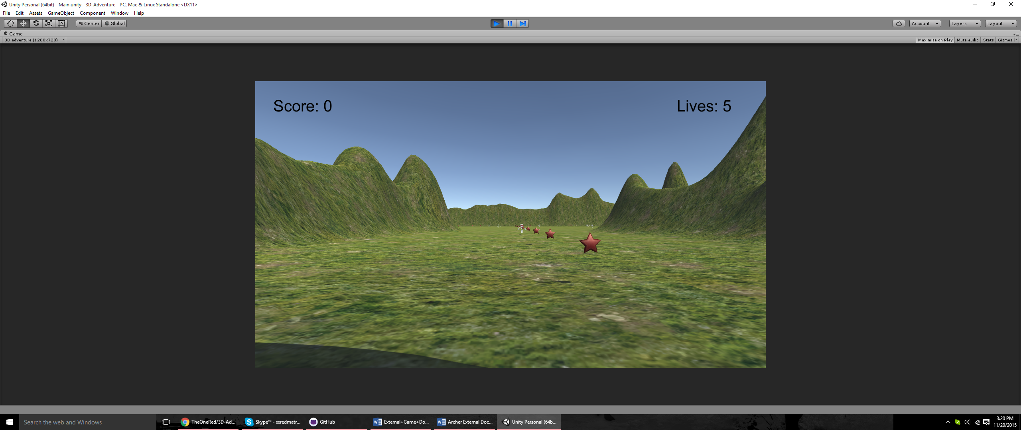

Player has collected points and can see enemy and pick-ups

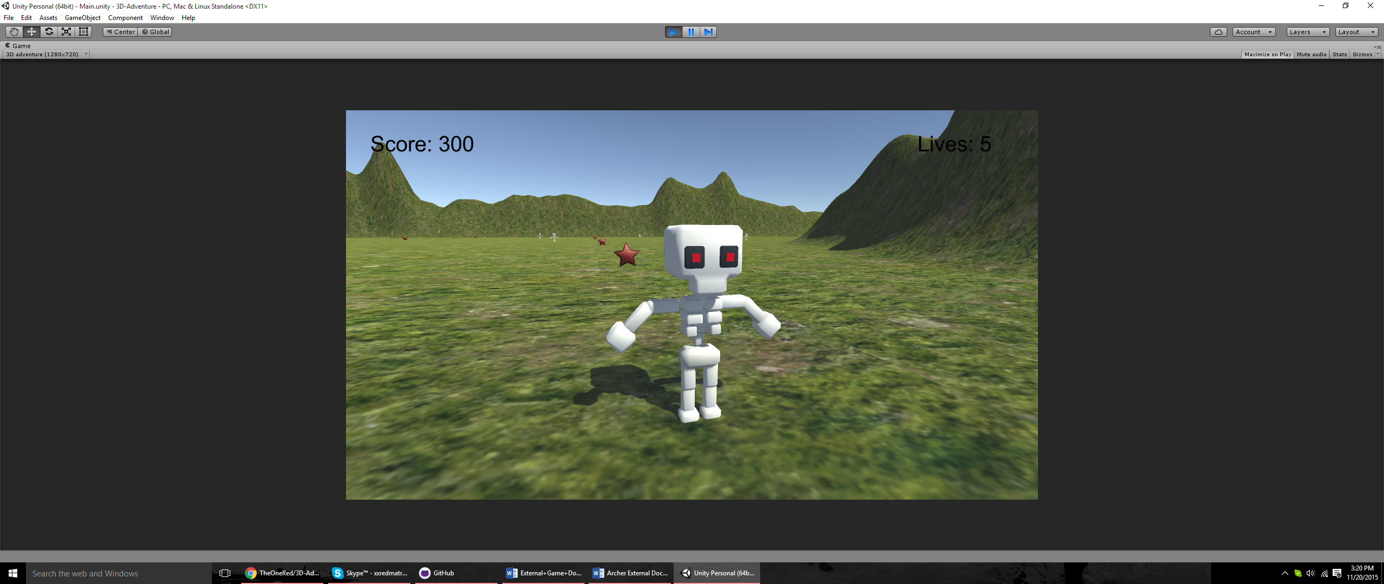

Game over Screen

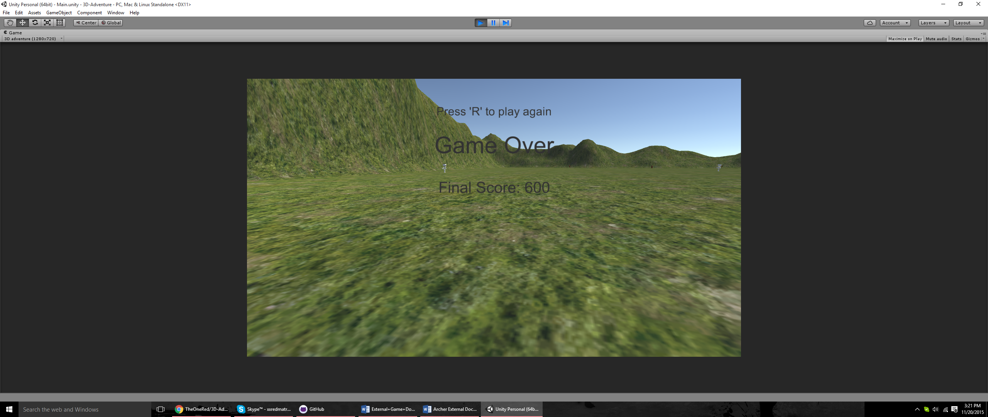

1. **Characters**

* Player has no model and is invisible

1. **Enemies**

* 3D Skeleton

1. **Scoring**

* Star = 100 points
* Touching an enemy = -1 Life

1. **Sound Index**

* Pickup – Bounce 15 - Arcade SFX Free / Unity Asset Store
* Footsteps – Footstep 1-4 – FirstPersonView / Unity Asset Store
* Jump – Jump – FristPersonVIew/ Unity Asset Store

1. **Art / Multimedia Index**

Skeleton

<https://www.assetstore.unity3d.com/en/?gclid=Cj0KEQjw4NmvBRCRp_yu2bzal4YBEiQAWfjpJmr8mRrLEnQ66wzQQykokNxHOvSjOIDWu08a764Ho4YaAhPu8P8HAQ#!/content/48899>

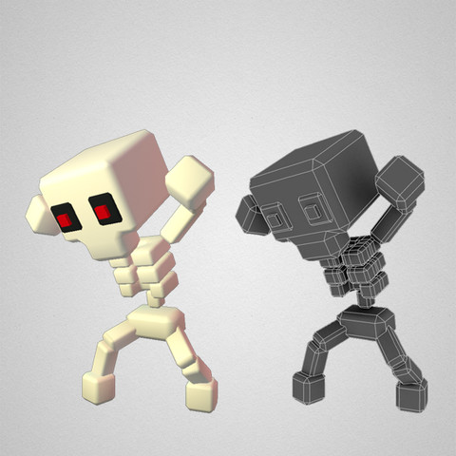

Star <https://www.assetstore.unity3d.com/en/?gclid=Cj0KEQjw4NmvBRCRp_yu2bzal4YBEiQAWfjpJmr8mRrLEnQ66wzQQykokNxHOvSjOIDWu08a764Ho4YaAhPu8P8HAQ#!/content/36106>

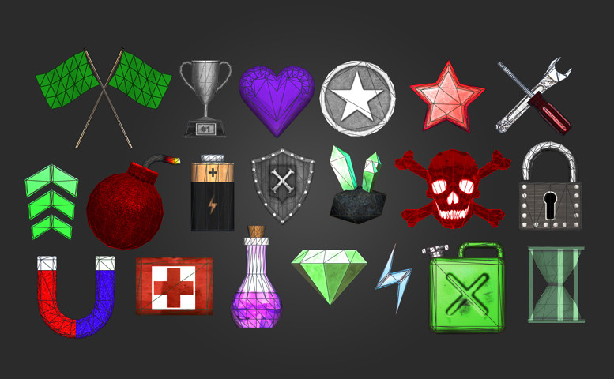

Terrain Texture given in Unity